Purpose:
The module is written in Python and demonstrates how the environment plays a major role in providing agents with percept(input) and how agents act upon its percept, and how environment react upon agent’s action.
​
Key Class:
BlindDog and Park class are the key classes in this program that demonstrate the purpose of this module.
- BlindDog is inherited from the Agent. It is a specialized agent that acts in specific ways based on particular percepts provided by the environment. There are total of four actions BlindDog Class to do and they are eat, drink, bark, and move down.

- Park is an inherited Class from the environment. It is a specialized environment that will react to the agent's actions. In this program park will delete object belong to Class Food, Water, and Person depend on the action the agent does.

High-level Overview:
​
- The percept provided by Class Park will be a list of objects with a location attribute that are instances of Class Thing.

- Based on the elements of the list, where each element is an instance of Class Thing provided by the environment(Park), the agent will act upon it accordingly.

- After the agent acts upon a percept, which is an element in the list provided by the Park, the environment will delete an element in the percept list according to the action the agent took.

- If the agent at a particular location does not have a percept, it will move down to its next location.

- The program will end if the provided number of agent actions is reached or there are no percepts such as food, water, or a person left.

Changes to the code:
- Added the new percept, which is Class Person, inherited from Class Thing
  - class Person(Thing):
  - pass

- For the agent to act according to the new percept Class Person, .program() also needs to be modified
  - elif isinstance(p, Person):
  - return 'bark'

- Because there is a new action added to the agent, the reaction from the environment must also be modified
  - elif action == "bark":
  - items = self.list_things_at(agent.location , tclass=Person)
  - if len(items) != 0:
  - if agent.bark(items[0]):
  - print('{} barked at {} at location: {}'
  - .format(str(agent)[1:-1], str(items[0])[1:-1], agent.location))
  - self.delete_thing(items[0])

UML Class Diagram:
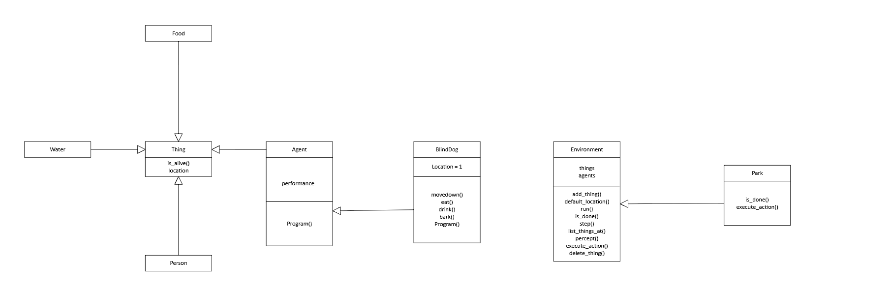

Execution Flow:

Snipped Code:

candy = Food()
park.add_thing(candy, 9)

Yiming = Person()
park.add_thing(Yiming, 3)

Ding = Person()
park.add_thing(Ding, 12)

park.run(18)

candy = Food()
- The variable candy is an instance of Class Food
- Class Food inherits from the abstract class Thing
- Initializing an instance of Class Food and assigning it to the variable candy

park.add_thing(Candy, 9)
- add_thing() is a method from Class Park that is inherited from Class Environment
- This method adds any object to the attribute list things of Class Environment and assigns a location attribute to that object.
- If location is not provided in the parameter, the default_location() method is invoked to assign a default location to the location attribute of the object.
- default_location() is a method from the Class Environment, and it returns None.
- In this case, the object candy is inserted into the thing list, an attribute of Class Environment. The location attribute is assigned to the object candy with the value of 9.

Yiming = Person()
- Class Person is inherited from Class Thing
- An instance of Class Person is assigned to variable Yiming

park.add_thing(Yiming, 3)
- Object Yiming is inserted into the things list; an attribute belongs to Class Environment.
- The location attribute with the value of 3 is assigned to object Yiming.

Ding = Person()
- An instance of Class Person is assigned to variable Ding

park.add_thing(Ding, 12)
- Object Ding is inserted into the things list, an attribute belonging to Class Environment.
- The location attribute with the value of 12 is assigned to object Din.g

park.run(18)
- .run() is a method from Class Park inherited from Class Environment
- It checks if the program is done by invoking the method .is_done()
  - .is_done() is an overloaded method from Class Park that is inherited from Class Environment
  - It returns false if there is an element in the attribute agent list from Class Environment that has the attribute alive, where alive is true.
- If it is not done, invoke the method .step()
  - .step() is a method from Class Environment
  - The first actionable action of the agent is appended to the list of actions belonging to Class Environment by invoking the methods .percept() and .program()

    - .percept is an overloaded method from Class Park inherited from Class Environment
    - It invokes the method .list_things_at() to obtain a list of percepts at the desired location
    - .program() method is an overloaded program from Class BlindDog
    - This method returns an action according to the first actionable element in the list provided by the .percept() method
  - Because the .program() method only returns the first actionable action from a list provided by the .percept() method, the .zip() method will combine the agent list and action list and execute the action by invoking the .execute_action() method.
- .execute_action() method is an overloaded method from Class Park, inherited from Class Environment
- Depending on the agent and the action provided in the parameter, it will get the element from the list thing from Class Environment according to the Class the action is associated with and the location of the agent, and append it to a list named items.
- It will delete the first instance of the first element of items from the list thing.
- If the action is moving down, the location of the agent is increased by .one

Overview of park.run(18)
- In the case of the whole program, the list agents from the Class Park is occupied by 1 element, which is dog, an instance of class BlindDog
- The list things from the Class Park is occupied by 5 elements, and they are dogfood with location equal to 5, water with location equal to 7, Yiming with location equal to 9, dogfood with location equal to 3, and lastly Ding with location equal to 12.
- According to the Class of each element in the list of things, the dog object will execute differently.
- The program will end upon reaching the action count provided by the run () method, which is 18, or if there are no edibles in the park environment.
- In this case, the program ended at action 12 because there were no edibles left in the park environment.

